Order Of Service

Singing: Psalm 1—CW page 64

Reading: Psalm 14

Opening Hymn: TLH 648

Reading: III John

Request Hymn: CW Supplement 702

Reading: John 2:13-22

Sermon Hymn: TLH 23

Sermon Text: Song Of Solomon 4:3b

Her Temples—A Pomegranate

Prayer

The Apostles’ Creed, TLH page 12

Holy Communion

The Lord's Prayer

The Blessing

Closing Hymn: TLH 45

* * * * * * * * * * *

Bible Study: Lambs: I Samuel 18:6-9; Be Happy With Your Friends
Sheep: Proverbs 10:23-24
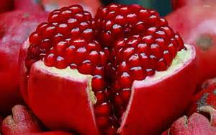
A Pomegranate

Water
Of
Life

31 July 2016

W A T E R O F L I F E

Independent Christian Church—Conservative Lutheran Doctrine

Worship Service: 9:30 a.m. Bible Study: 10:45 a.m.

Larry Cooper, Pastor E-Mail address:
111 N. Ridge Road lcooper@wateroflife.cc
Coon Valley, WI 54623 Web Site:
Phone: (608) 452-2105 www.wateroflife.cc

* * * * * * * * * * * * * * * * * * * * * * * * * * *

Sermon Text: Song Of Solomon 4:3b

Her Temples—A Pomegranate

* * * * * * * * * * * * * * * * * * * * * * * * * * *

Song of Solomon 4:3 Thy temples are like a piece of a pomegranate within thy locks.

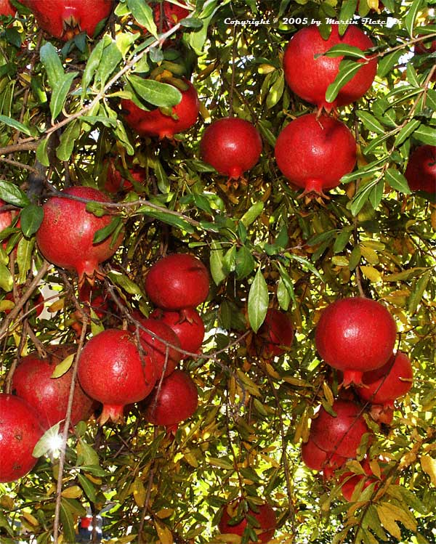

Pomegranates

Pomegranates are mentioned some 32 times in the Old Testament. It is of special interest that they are among the things mentioned by Moses when describing the Promised Land:

Deuteronomy 8:7 For the LORD thy God bringeth thee into a good land, a land of brooks of water, of fountains and depths that spring out of valleys and hills;
:8 A land of wheat, and barley, and vines, and fig trees, and pomegranates; a land of oil olive, and honey;
:9 A land wherein thou shalt eat bread without scarceness, thou shalt not lack any thing in it; a land whose stones are iron, and out of whose hills thou mayest dig brass.

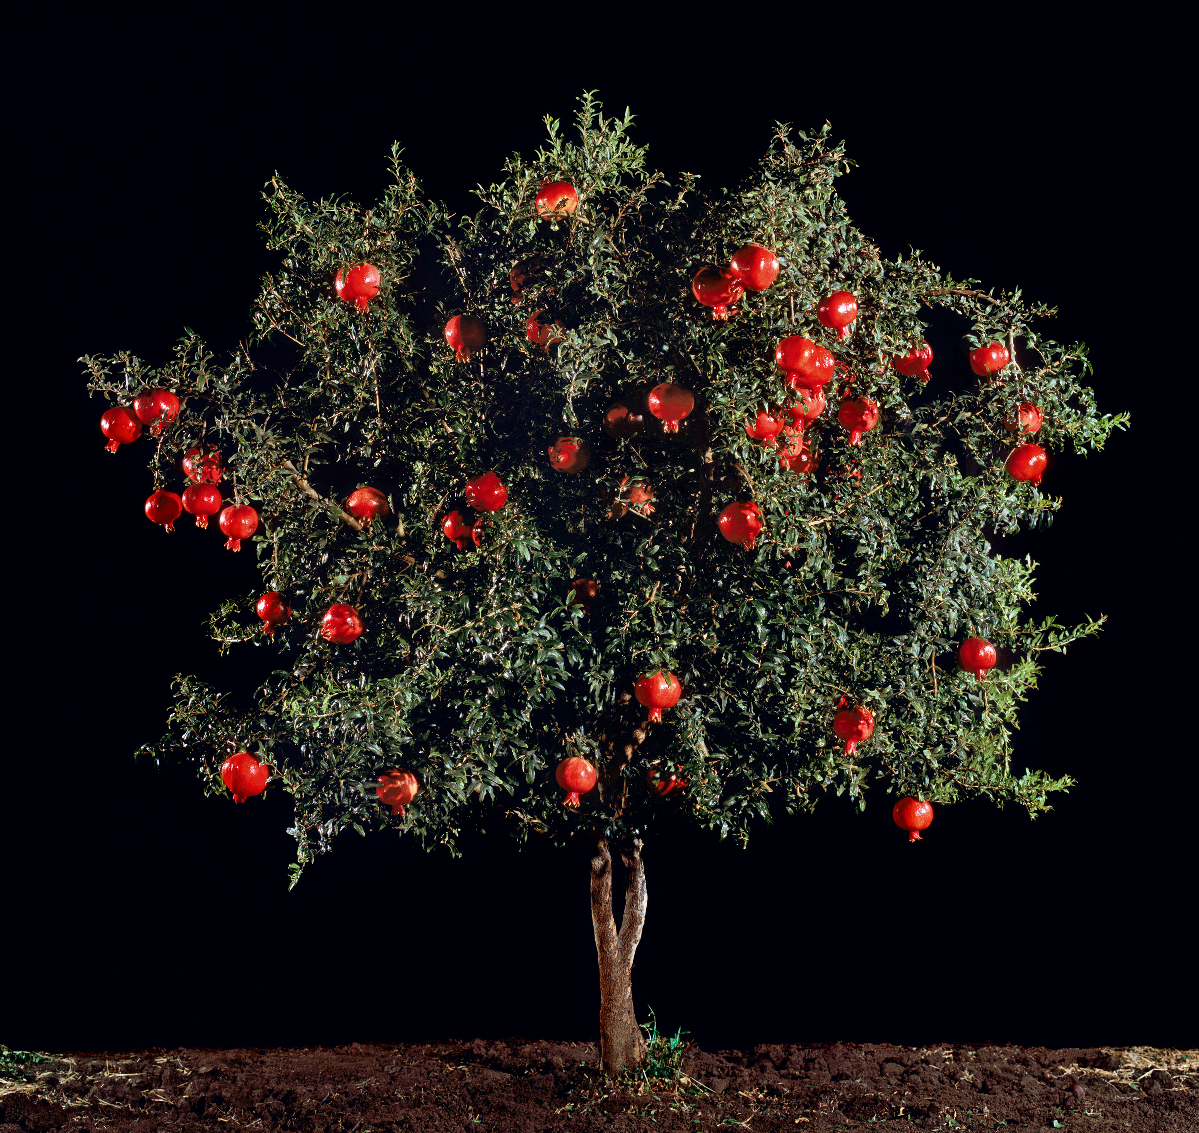

Pomegranate trees are beautiful trees, and the fruit which they produce is refreshing and highly valued. The pomegranate is a fitting description of the temples of the Bride of Jesus Christ.

We’ll pray for the guidance of the Holy Spirit as we meditate upon his words to us in Song of Solomon 4:3 this morning.

